Assignment - 2

Python Programming

|  |  |
| --- | --- |
| Assignment Date | 19 September 2022 |
| Student Name | Preethi B |
| Student Roll Number | 2019504048 |
| Maximum Marks | 2 Marks |

Question:

Build a python code, assume u get temperature and humidity values (generated with random function to a variable) and write a condition to continuously detect alarm in case of high temperature.

Solution:

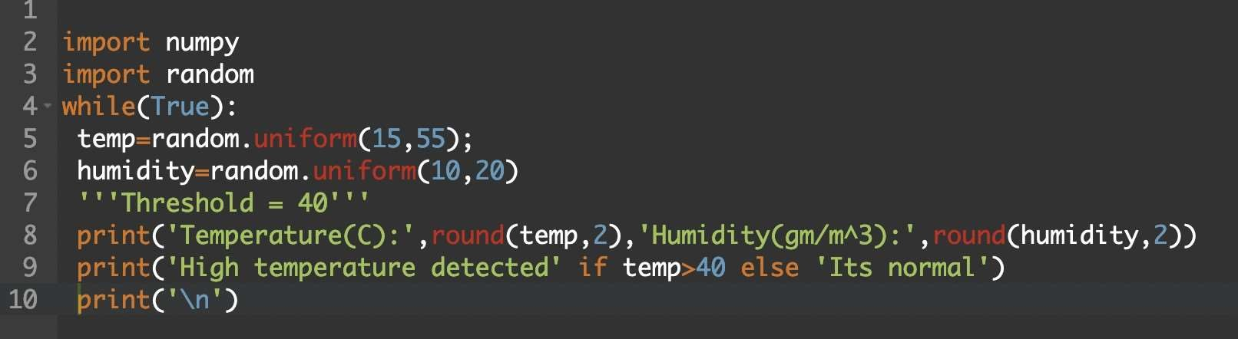

Output:

